## FPT ACADEMY INTERNATIONAL FPT – APTECH COMPUTER EDUCATION



### Centre Name: ACE-HCMC-2-FPT.

**Address: 590 Cach Mang Thang 8, District 3, Ho Chi Minh City, Viet Nam.**

Bronx Luggage

|  |  |  |
| --- | --- | --- |
| **Supervisor:** | Ms. Le Mong Thuy | |
| **Semester:** | 1 | |
| **Batch No:** | T1.2406.M1 | |
| **Group No:** | 2 | |
| **Order:** | **Name** | **Student ID** |
| 1. | Nguyen Minh Nhan | Student1571988 |
| 2. | Duong Tan Phat | Student1572000 |
| 3. | Ho Anh Toan | Student1571987 |

Date: September - 2024

### This is to certify that

**Mr.** Nguyen Minh Nhan

**Mr.** Duong Tan Phat

**Mr.** Ho Anh Toan

### have successfully designed & developed:

eProject: Bronx Luggage

### Submitted by:

Ms. Le Mong Thuy

**Date of issue: Octemper** 14th 2024

### Authorized Signature:

**Table of Contents**

Table of Contents

FPT ACADEMY INTERNATIONAL FPT – APTECH COMPUTER EDUCATION 1

Centre Name: ACE-HCMC-2-FPT. 1

This is to certify that 2

have successfully designed & developed: 2

Submitted by: 2

Authorized Signature: 2

ACKNOWLEGMENT 4

SYNOPSIS 4

ANALYSIS 4

1. Purpose of the Website. 4

2. Design and Interface. 4

3. Technical Requirements 5

CUSTOMER'S REQUIREMENTS SPECIFICATIONS 5

Client: Bronx Luggage 5

1. Business/Project Objective 5

2. Hardware/ Software Requirements 6

2.1 Hardware 6

2.2 Software 6

SCOPE OF THE WORK (IN BRIEF) 7

1. Home: 7

2. About us 7

3. Gallery 7

4. BLOGS (Feedback): 7

5. Sitemap: 7

6. Feature Brand: 7

7. Contact us: 7

ARCHITECTURE AND DESIGN OF THE SYSTEM 8

DIAGRAM OF THE WEBSITE 9

TASK SHEET REVIEW 1 10

Site Map 11

Mock of Website 12

Navigation Bar 12

Home 12

Feature Brands 13

Gallery 14

Blogs 15

Contact Us 16

Task Sheet Review 2 17

Problem Defination 18

1. Requirement 1: 18

*1.1. Logo:* 18

*1.2. Header with Navigation Bar:* 18

18

*1.3. Homepage:* 18

2. Requirement 2: 19

*2.1. Various types of Luggage:* 19

*2.2 Various types of Bags:* 19

*2.3. Various Type of Backpacks:* 20

3. Requirement 3: Filter 20

*3.1. Filter by size:* 20

*3.2. Filter by Brands:* 20

*3.3. Filter by Price:* 21

*3.4. Filter by Color:* 21

4. Requirement 4: For Men and Women 21

*4.1. For Women:* 21

*4.2. For Men:* 22

5. Requirement 5: 22

*5.1. Price along with the images* 22

*5.2. Specification: When hover the mouse over the picture, the description will popout.* 22

6. Requirement 6: 23

*6.1. Various Brands* 23

7. Requirement 7: 23

*7.1. Rating by star:* 23

8. Requirement 8: Gallery 24

9. Requirement 9: Feedback 25

*9.1. Feebback with no typing, will alert to user.* 25

10. Requirement 10: 26

*10.1. Sitemap at footer:* 26

*10.2. Sitemap page* 26

*10.3. Galary link:* 26

*10.4. Contact us, About us link:* 26

11. Requirement 11: 27

*11.1. Contact Us :* 27

*11.2.About us:* 27

12. Requirement 12: Functionalities 28

Task Sheet Review 3 30

## ACKNOWLEGMENT

On behalf of team members. I would like to thank everyone who supported my team to successfully complete this eProject report. Especially, our teacher, she has supported us a lot since we started studying at FPT Aptect. With this eProject, she guided us very meticulously, enthusiastically and strictly. With her guidance, we were able to successfully complete this project. Besides, I also want to thank all the team members, each of whom worked hard to complete the eProject in earnest during the month of working together. Finally, our group would like to say thank you to my classmates and family for sharing and creating for the group the best environment to focus on the project, motivating the members to achieve their goals.

## SYNOPSIS

The beauty of receiving high quality luggage is a truly amazing feeling. Great luggage can be passed down from family members who are experienced travelers. A high-quality set of luggage will last a lifetime.

Bronx Luggage, located in the Festival Marketplace, offers a wide selection of luggage from affordable sets to the best brands on the market for all of your travel needs. We also stock Backpacks, travel accessories, briefcases and much more.

We are supposed to create a Single-Page-Application and responsive Website for them with the below mentioned requirement specifications

## ANALYSIS

### Purpose of the Website.

The portal will be designed as a Single-Page-Application and responsive Website with a set of pages and menus that represent choice of activities to be performed. The pages, menus, and other visual elements must be designed in a visually appealing manner with attractive fonts, colors, and animations.

### Design and Interface.

* + The website features a user-friendly environment and navigation. Key menus are positioned at the top for easy access to information.
  + The interface and color scheme are harmoniously combined to create a visually appealing and engaging experience for users.

### Technical Requirements

* + The website must perform well across all major browsers including Chrome, IE, Firefox, etc., ensuring accessibility from various devices and platforms.
  + It utilizes a Single-Page-Application (SPA) approach to deliver a seamless and fast web browsing experience.
  + Features are designed to meet technical requirements, facilitating quick and accurate loading and display of information.

## CUSTOMER'S REQUIREMENTS SPECIFICATIONS

### Client: Bronx Luggage

### Business/Project Objective

The portal will be designed as a Single-Page-Application and responsive Website with a set of pages and menus that represent choice of activities to be performed. The pages, menus, and other visual elements must be designed in a visually appealing manner with attractive fonts, colors, and animations.

All of these should also be laid out in a responsive manner

The Web site is to be created based on the following requirements.

1. The Home Page should be created making use of Sections with a suitable logo, the header section can be added which will show images of various Luggage’s and Bags.
2. The site must contain the sections to navigate through various types of Luggage, Bags and BackPacks etc.
3. Filter for various sizes, colour, price, brands should be provided.
4. Site should have different section for Men and Women with products placed accordingly.
5. Specification and Pricing of Bags should be added along with the images.
6. Website should provide section for various brands offered in the store.
7. Ratings by the user for products should be allowed by the user.
8. Gallery section should be added for viewing different images.
9. Feedback must be allowed to enter by the viewer
10. Site map, Gallery, about us, Contact us link must be added.
11. About Us and Contact Us: This menu option should display Email id, address, and contact number of the organization who is developing the system.

Over and above this, the portal should implement the following functionalities:

* Display a continuous scrolling ticker at the bottom of the page with current date, time, and location (hint: Use geolocation features of HTML5).
* Display a visitor count at the top right corner of the page beside a logo image.
* The menu options should change color on hover and also after clicking.
* Fade in and fade out options can be used for the menus.

### Hardware/ Software Requirements

### Hardware

* + - Intel Core i3/i5 Processor or higher
    - 8 GB RAM or above
    - Color SVGA
    - 500 GB Hard Disk space
    - Mouse
    - Keyboard

### Software

Technologies to be used:

* + - Frontend: HTML5, CSS, Bootstrap, JavaScript, jQuery, React/AngularJS, Figma, XML
    - Data Store: JSON files or TXT files Other Requirements:
    - Operating Portal: Windows
    - Browsers: Edge, Chrome, Mozilla Firefox, Safari

# SCOPE OF THE WORK (IN BRIEF)

### Home:

* + Displays an overview of Luggage for everyone, our story, contact.

### About us

* + **Email:**
  + **Adress:**
  + **Contact number:**

### Gallery

* + **Videos:** A list of luggage, bags, Backpacks, travel accesssories, briefcase related videos.
  + **Images:** A photo gallery featuring luggage, bags, Backpacks, travel accesssories, briefcase…

### BLOGS (Feedback):

* + User can write their experiences and customer feedback here

### Sitemap:

* + Location of our company through Google map.

### Feature Brand:

* + Janport Backpacks
  + Brigg & Rilley
  + TRAVELPRO
  + BRIC’S
  + SAMSONITE
  + DELSEY|RICARDO
  + AFFORDABLE BRANDS

### Contact us:

* + Information for users to reach out or send feedback.

## ARCHITECTURE AND DESIGN OF THE SYSTEM

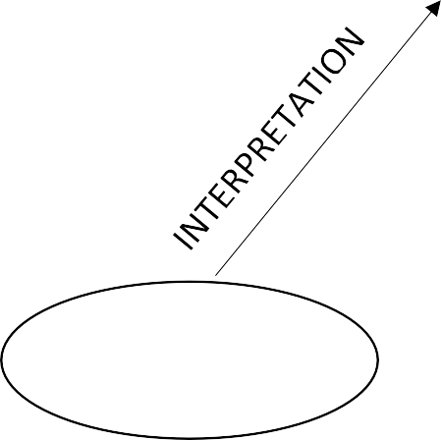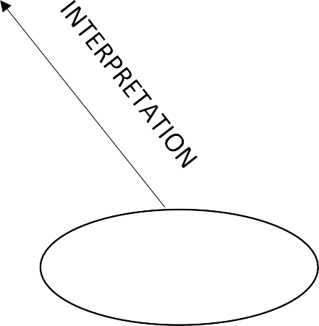

**CLIENT**

**WEB BROWSER**

Requested Page

**RENDERING**

**ENGINE**

**CSS CODE**

**BOOTSTRAP**

**HTML CODE**

**REACT**

**SERVER**

**WEB SERVER**

Webpage request

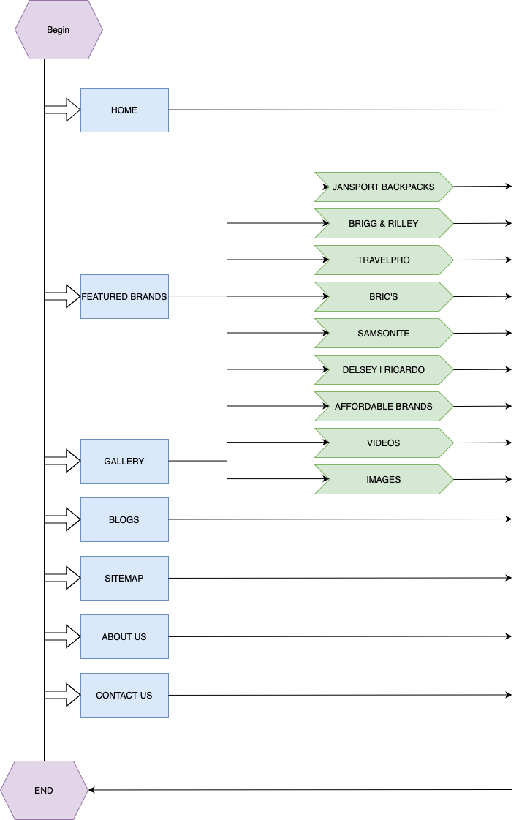

# DIAGRAM OF THE WEBSITE

# TASK SHEET REVIEW 1

|  |  |  |  |  |  |  |  |
| --- | --- | --- | --- | --- | --- | --- | --- |
| **Project Ref. No.: eP/Advertisement Portal Management System/01** | | **Project Title:** | **Activity Plan Prepared By:** | **Date of Preparation of Activity Plan:** | | | |
| **Sr.No** | **Task** | **Actual Start Date** | **Actual Days** | **Team Mate Names** | **Status** |
| 1 | Synopsis | Bronx Luggage | Nhan | 15/09/24 | 1 | Nhan, Phat | Completed |
| 2 | Analysis | 15/09/24 | 1 | Completed |
| 3 | The scope of the work (in brief) | 15/09/24 | 1 | Completed |
| 4 | Architecture and design of the system | 15/09/24 | 1 | Completed |
| 5 | Diagram of the website | 15/09/24 | 1 | Completed |
| 6 | Task Sheet Review | 15/09/24 | 1 | Completed |

|  |  |
| --- | --- |
| **Date: 16 Sept 2024** | |
| Signature of Instructor:  **Le Mong Thuy** | Signature of Team Leader:  **Nguyen Minh Nhan** |

# Site Map

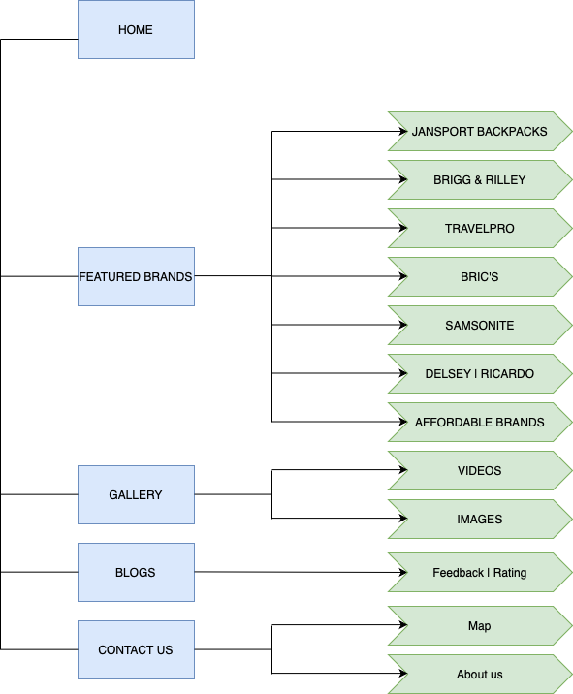

# Mock of Website

## Navigation Bar

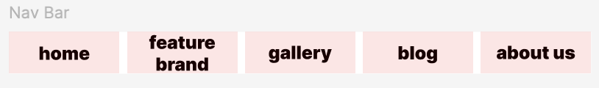

## Home

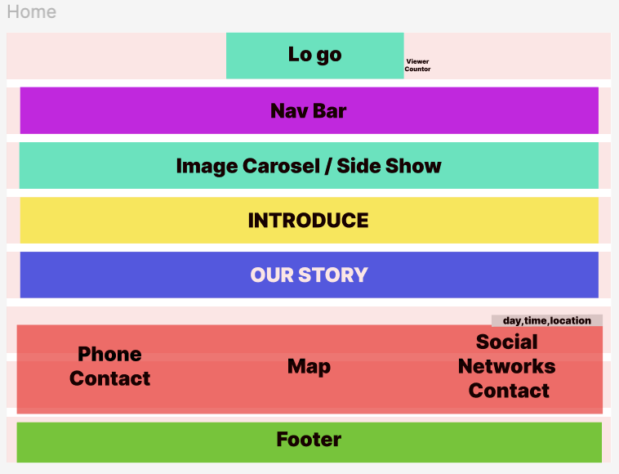

## Feature Brands

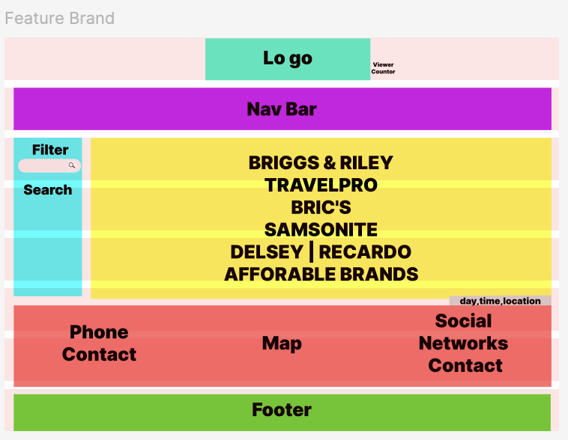

## Gallery

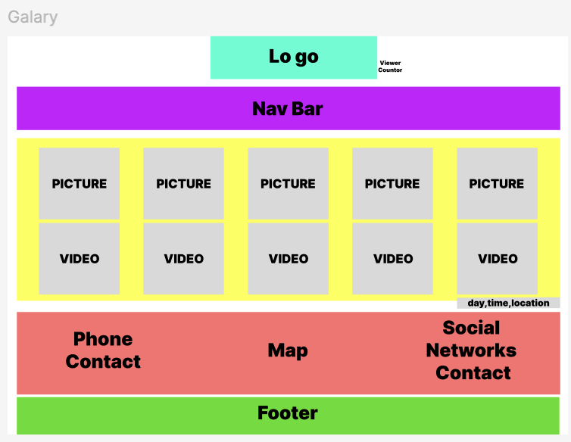

## Blogs

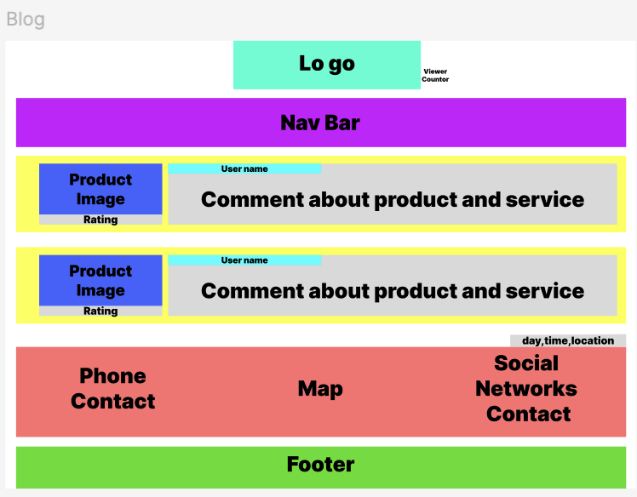

## Contact Us

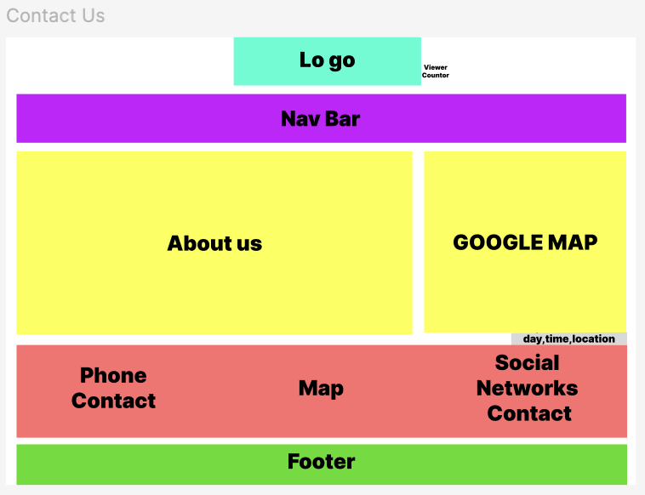

# Task Sheet Review 2

|  |  |  |  |  |  |  |  |
| --- | --- | --- | --- | --- | --- | --- | --- |
| **Project Ref. No.: eP/Advertisement Portal Management System/01** | | **Project Title:** | **Activity Plan Prepared By:** | **Date of Preparation of Activity Plan:** | | | |
| **Sr.No.** | **Task** | **Actual Start Date** | **Actual Days** | **Team Mate Names** | **Status** |
| 1 | Site map | Bronx Luggage | Nhan | 17/09/24 | 1 | Nhan, Phat, Toan | Completed |
| 2 | Mock of website | 1 | Completed |
| 3 | Task sheet Review 2 | 1 | Completed |

|  |  |
| --- | --- |
| **Date: 18th Sept 2024** | |
| Signature of Instructor:  **Ms. Le Mong Thuy** | Signature of Team Leader:  **Nguyen Minh Nhan** |

# Problem Defination

## 1. Requirement 1:

The Home Page should be created making use of Sections with a suitable logo, the header section can be added which will show images of various Luggage’s and Bags.

### *1.1. Logo:*



### *1.2. Header with Navigation Bar:*

### *1.3. Homepage:*

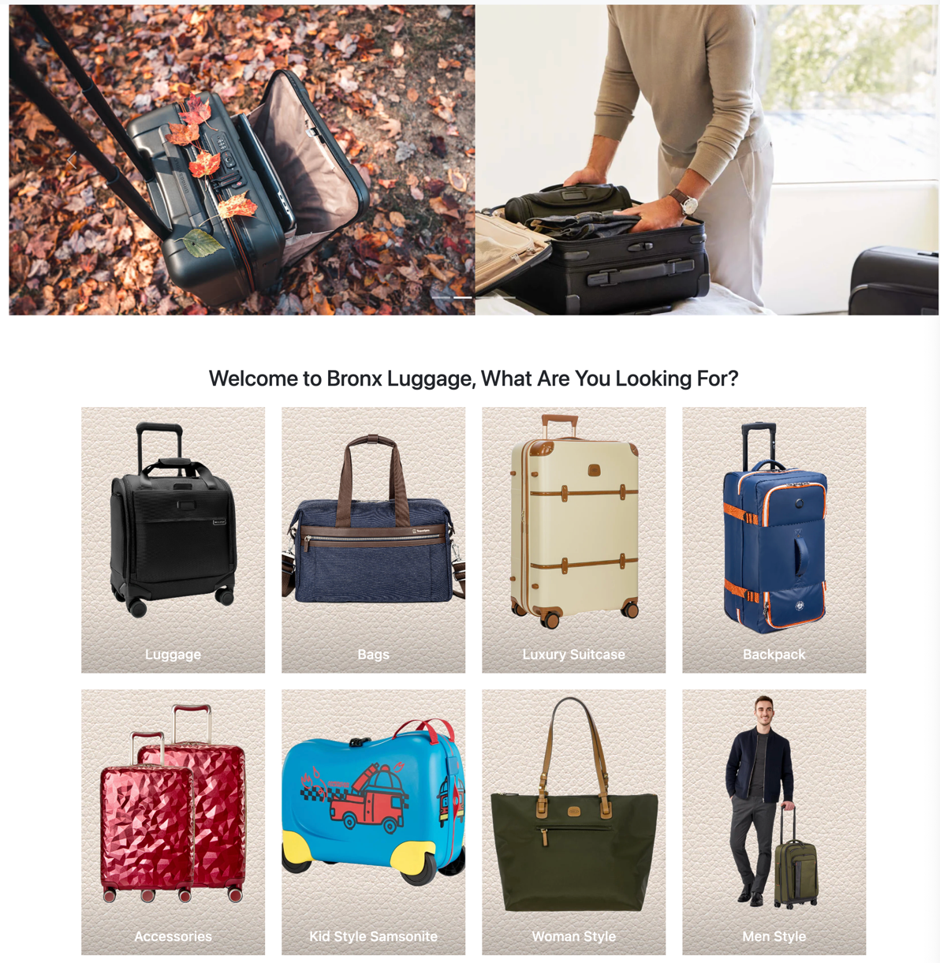

## 2. Requirement 2:

The site must contain the sections to navigate through various types of Luggage, Bags and BackPacks etc.

### *2.1. Various types of Luggage:*

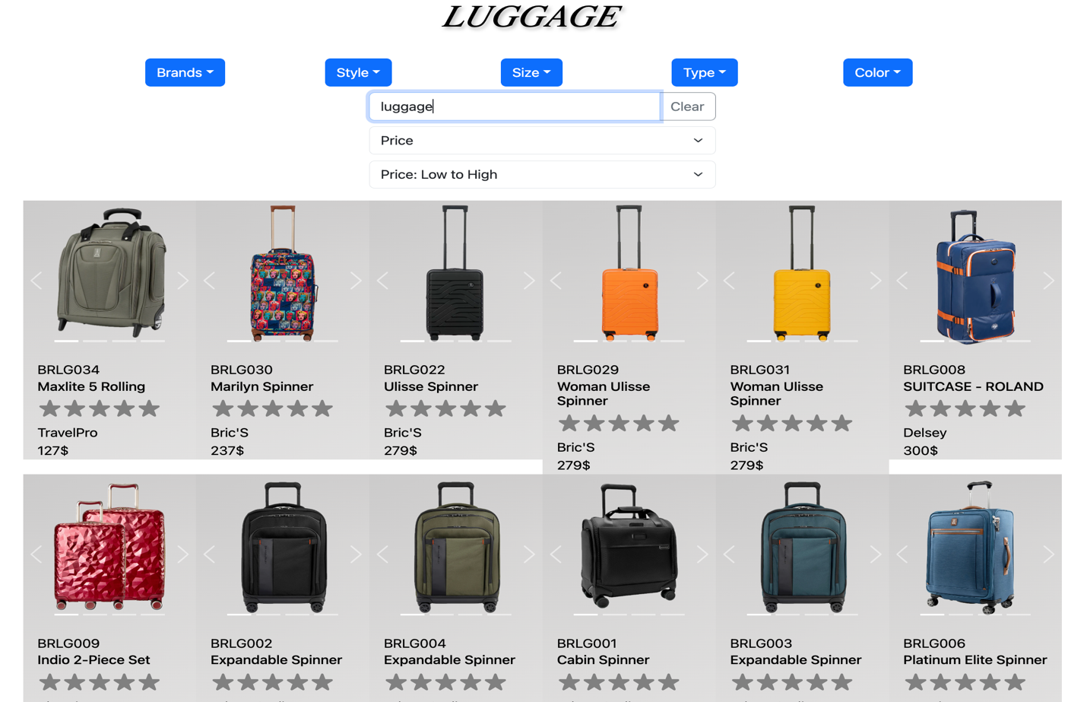

### *2.2 Various types of Bags:*

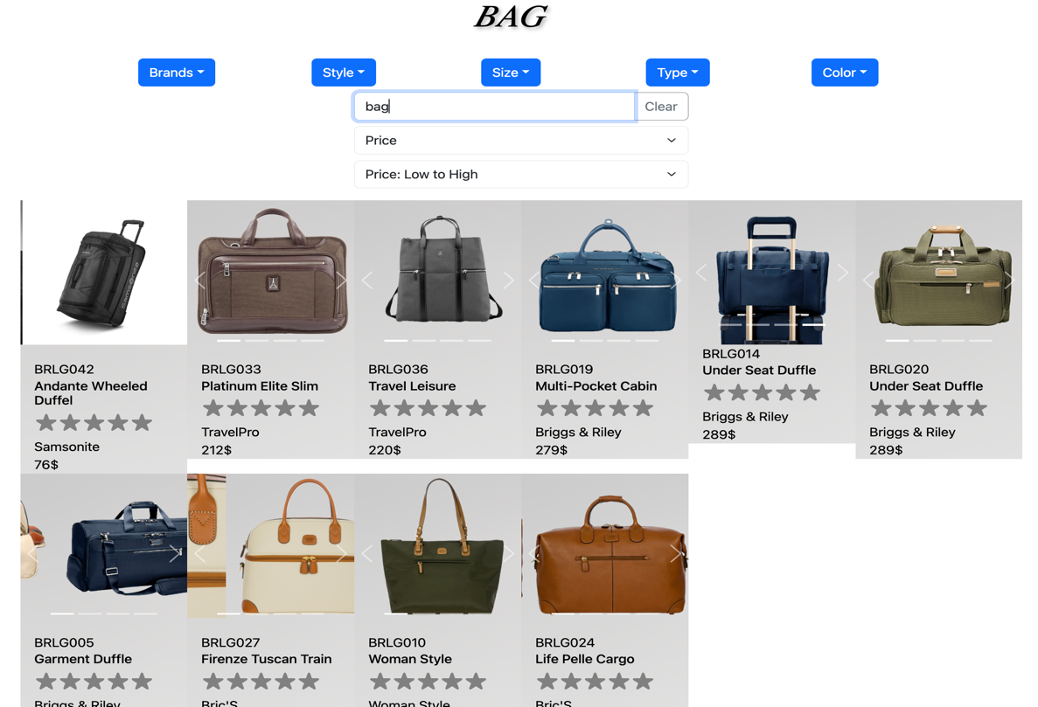

### *2.3. Various Type of Backpacks:*

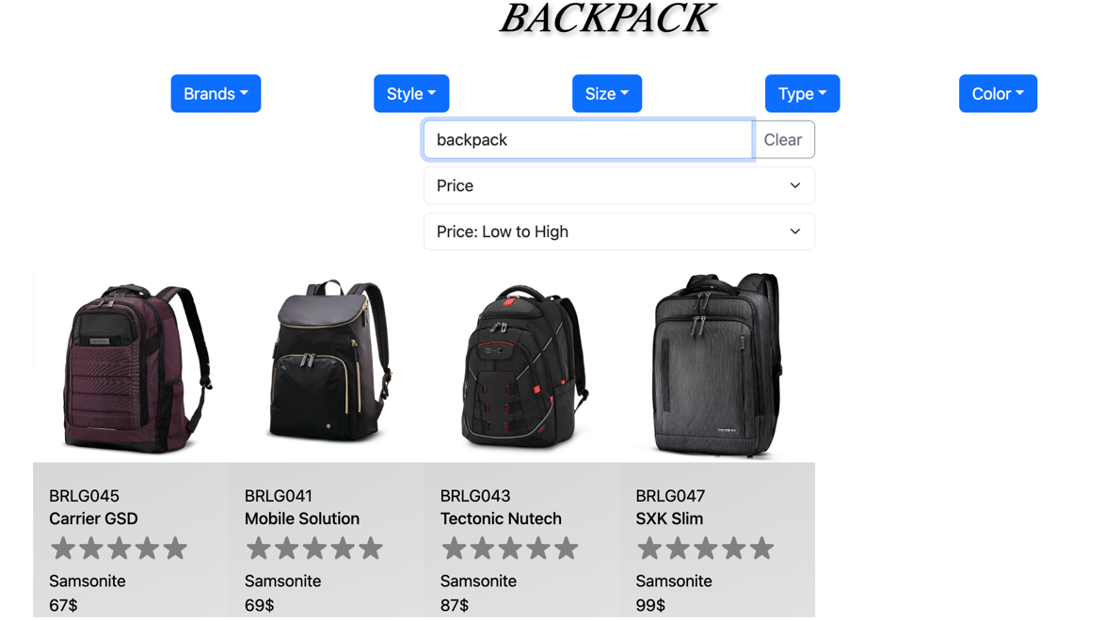

## 3. Requirement 3: Filter

Filter for various sizes, colour, price, brands should be provided.

*3.1. Filter by size:*

*3.2. Filter by Brands:*

### *3.3. Filter by Price:*

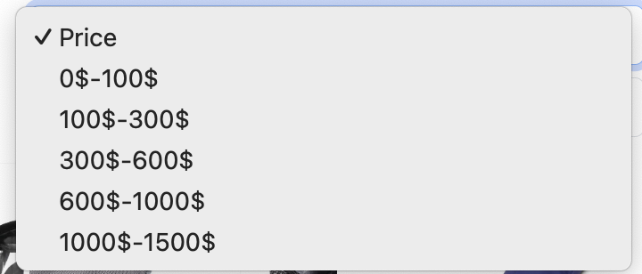

### *3.4. Filter by Color:*

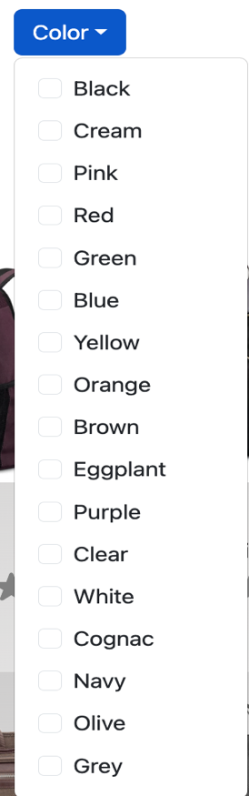

## 4. Requirement 4: For Men and Women

Site should have different section for Men and Women with products placed accordingly.

### *4.1. For Women:*

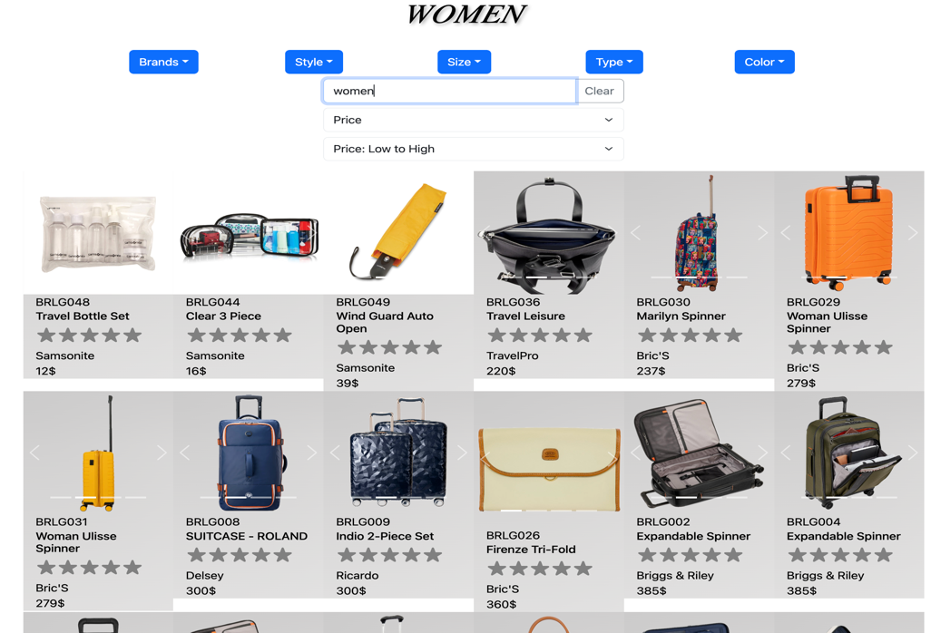

### *4.2. For Men:*

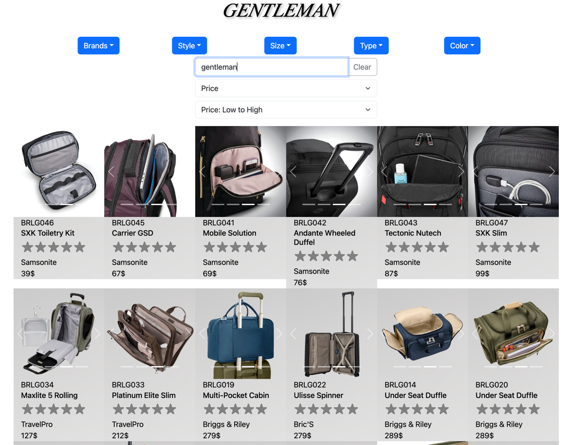

## 5. Requirement 5:

Site should have different section for Men and Women with products placed accordingly.

### *5.1. Price along with the images*

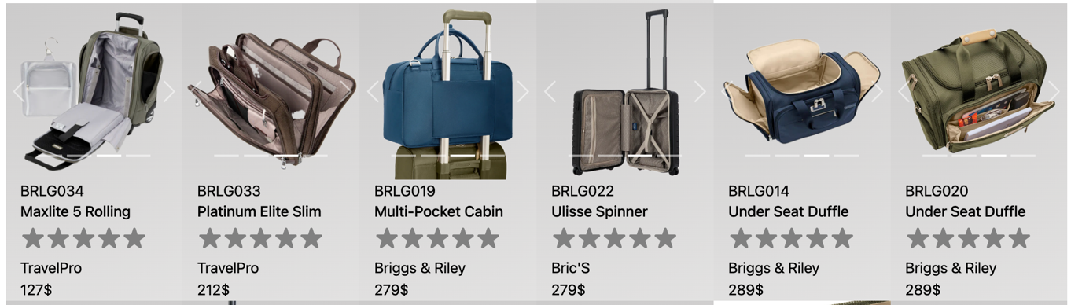

### *5.2. Specification: When hover the mouse over the picture, the description will popout.*

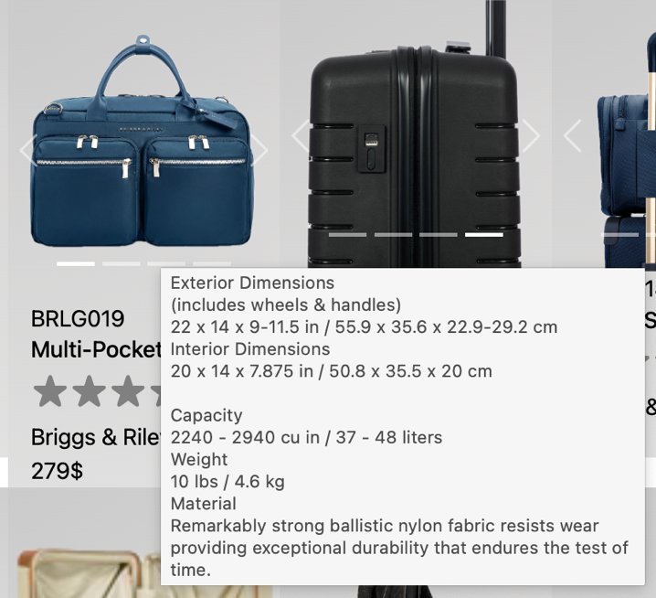

## 6. Requirement 6:

Website should provide section for various brands offered in the store

### *6.1. Various Brands*

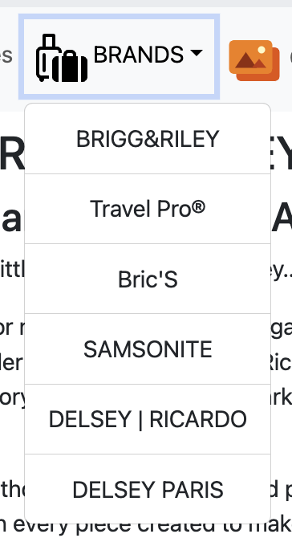

## 7. Requirement 7:

Ratings by the user for products should be allowed by the user.

*7.1. Rating by star:*

## 8. Requirement 8: Gallery

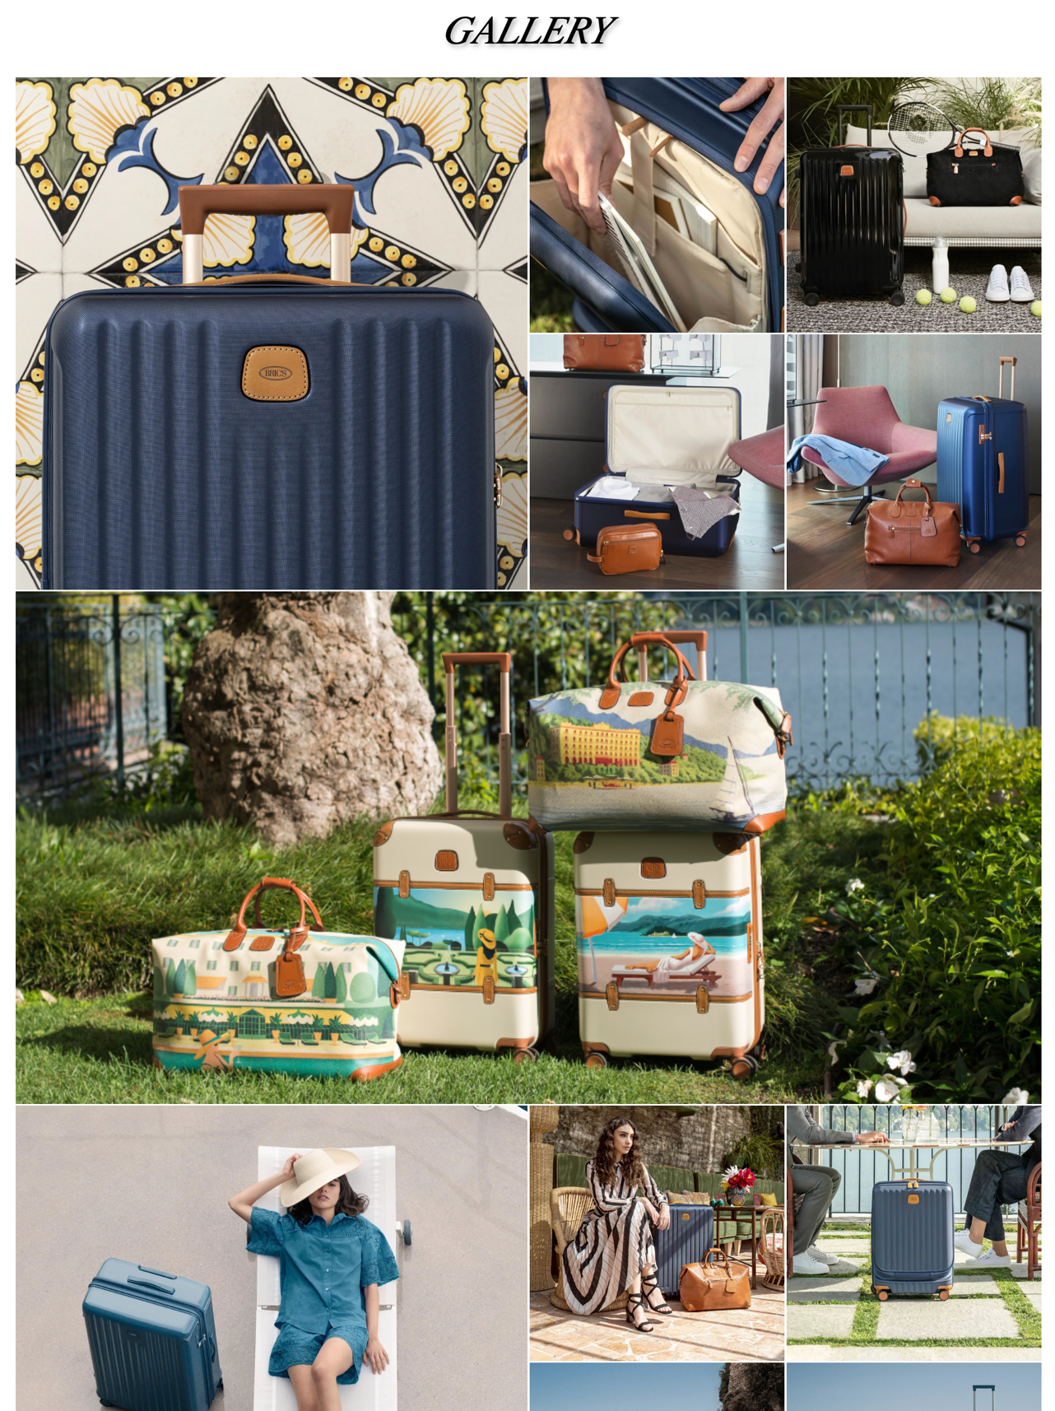

## 9. Requirement 9: Feedback

### *9.1. Feebback with no typing, will alert to user.*

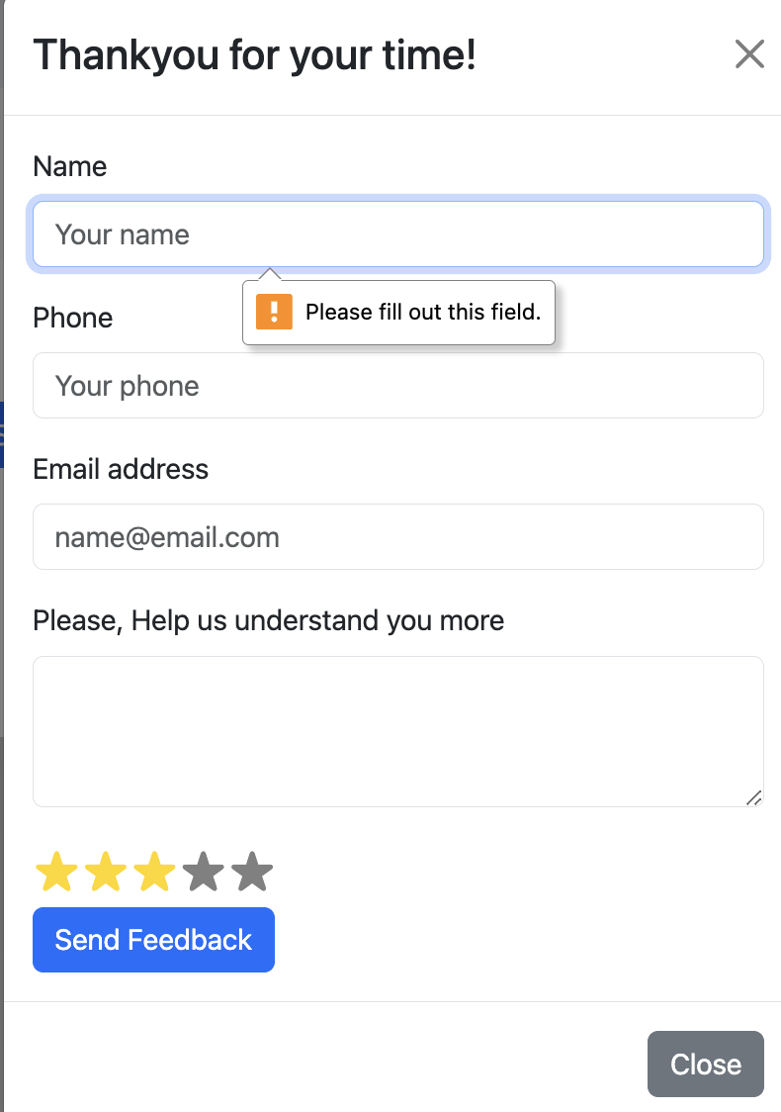

9.2. Feedback with Success:

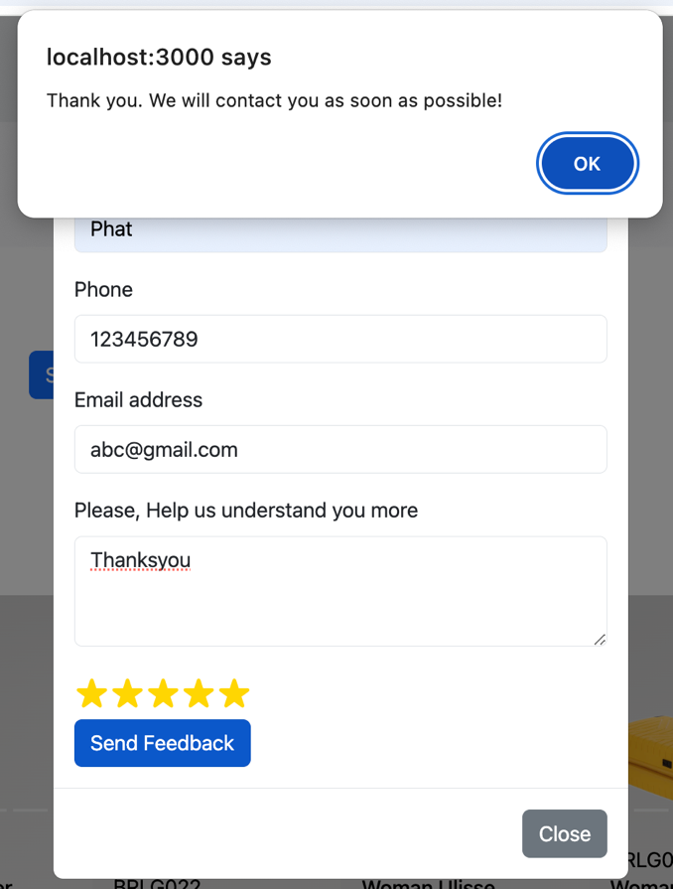

## 10. Requirement 10:

Site map, Gallery, about us, Contact us link must be added.

### *10.1. Sitemap at footer:*



### *10.2. Sitemap page*

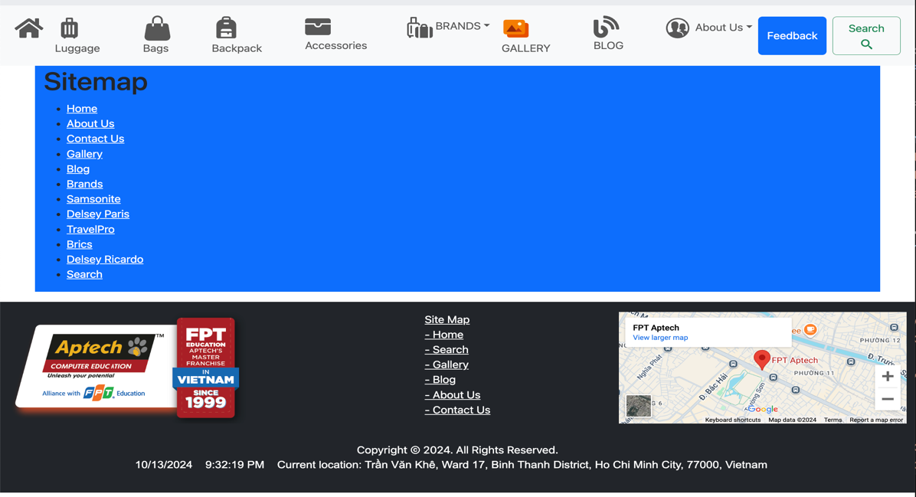

### *10.3. Galary link:*



### *10.4. Contact us, About us link:*

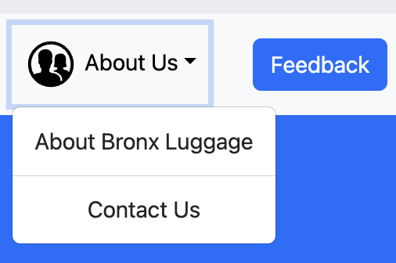

## 11. Requirement 11:

About Us and Contact Us: This menu option should display Email id, address, and contact number of the organization who is developing the system.

### *11.1. Contact Us :*

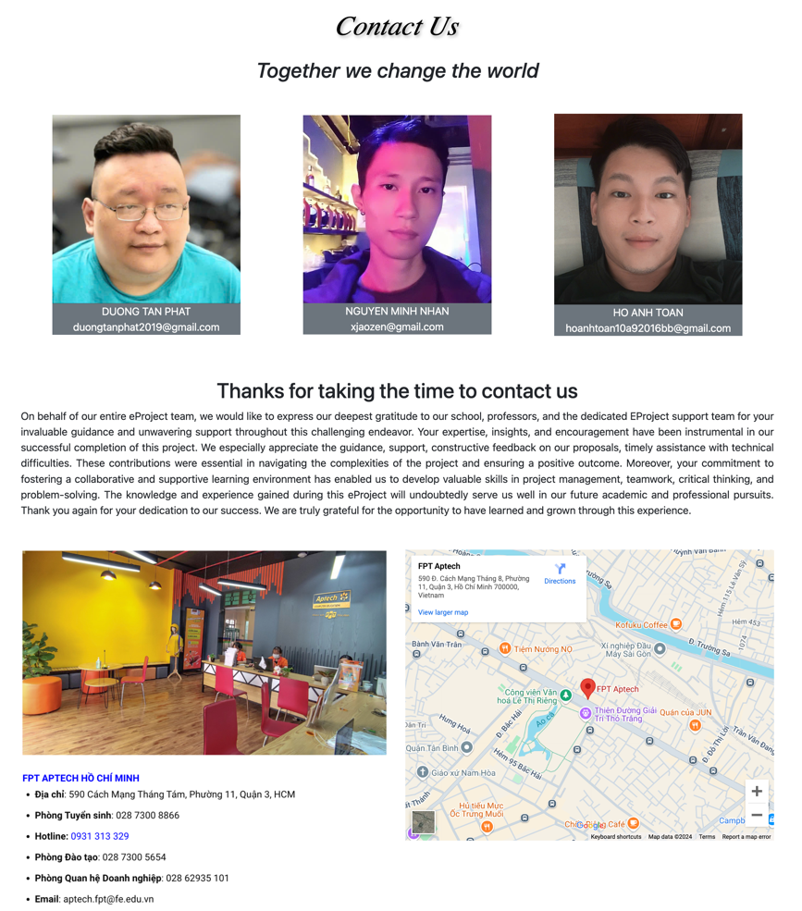

### *11.2.About us:*

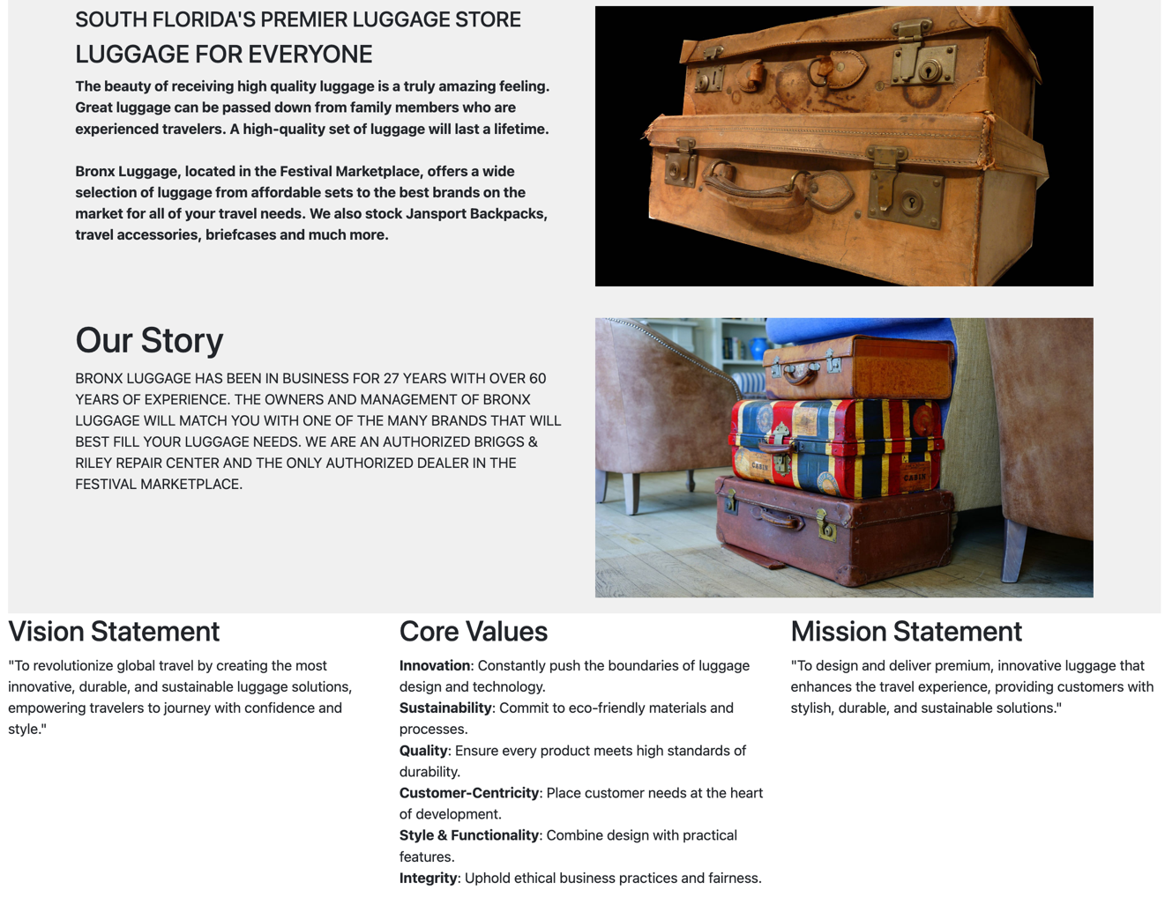

## 12. Requirement 12: Functionalities

*12.1. Display a continuous scrolling ticker* at the bottom of the page with current date, time, and location



*12.2. Display a visitor count* at the top right corner of the page beside a logo image

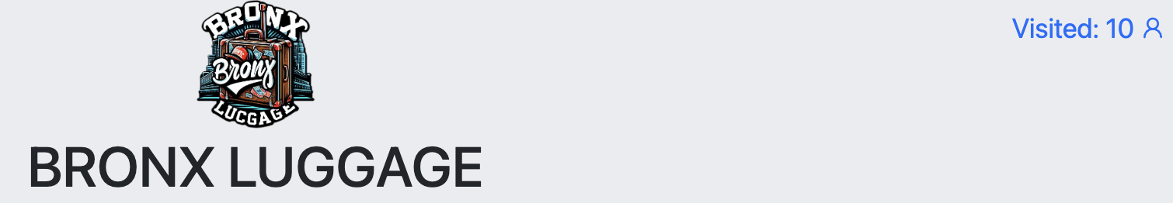

12.3 Respsonsive:

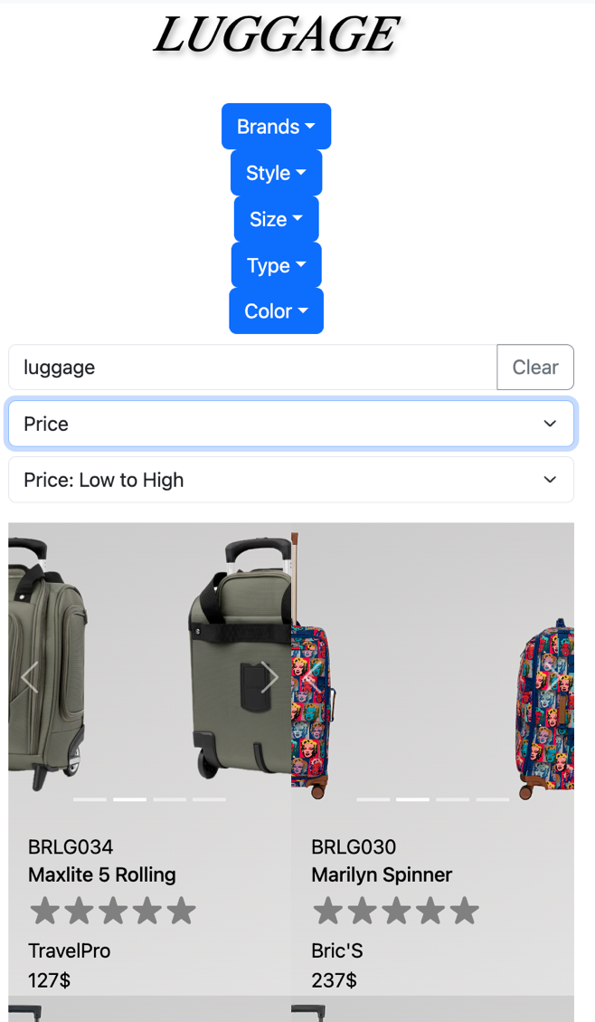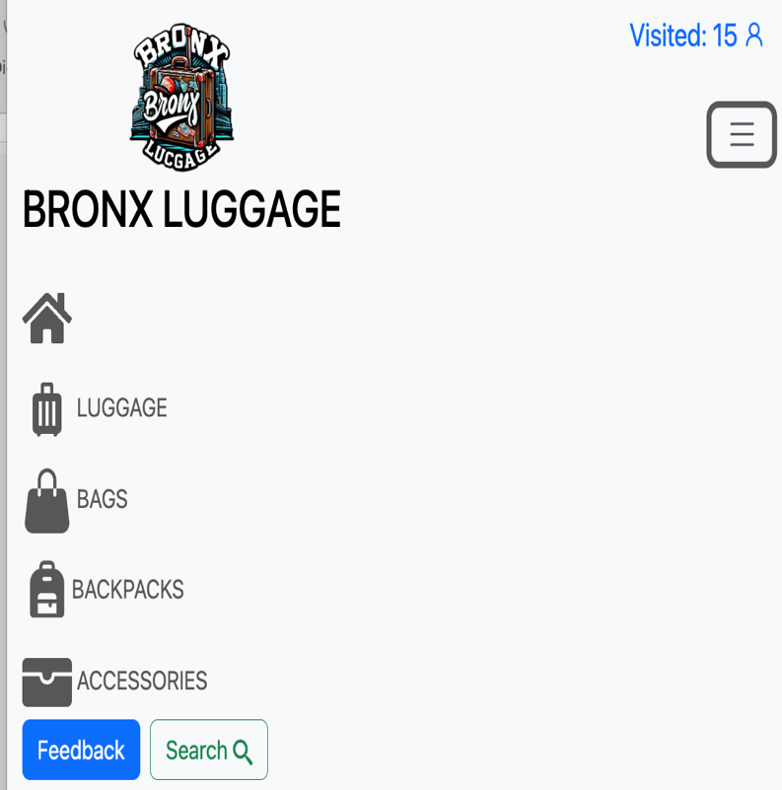

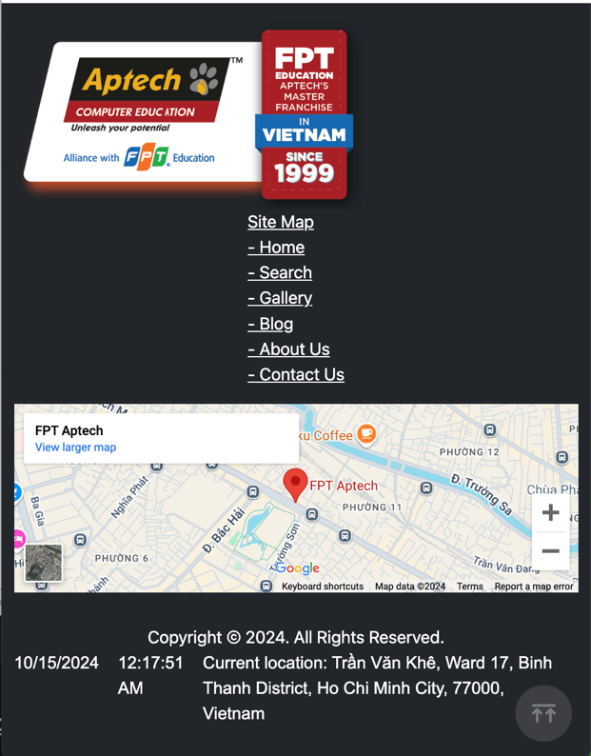

# Task Sheet Review 3

|  |  |  |  |  |  |  |  |
| --- | --- | --- | --- | --- | --- | --- | --- |
| **Project Ref. No.: eP/Advertisement Portal Management System/01** | | **Project Title:** | **Activity Plan Prepared By:** | **Date of Preparation of Activity Plan:** | | | |
| **Sr.No.** | **Task** | **Actual Start Date** | **Actual Days** | **Team Mate Names** | **Status** |
| 1 | Website Layout | Bronx Luggage | Nhan | 01/10/24 | 12 | Nhan, Phat, Toan | Completed |
| 2 | Report | 12 | Completed |
| 3 | Task sheet Review 3 | 12 | Completed |

|  |  |
| --- | --- |
| **Date: 14th Oct 2024** | |
| Signature of Instructor:  **Ms. Le Mong Thuy** | Signature of Team Leader:  **Nguyen Minh Nhan** |